IntelliMeet Pro: AI Meeting Assistant & Workflow Management
Software Design Specifications
Session Fall 2025
A 4th Year Student

BS in SE


Department of SE
Fast School of Computing
Fast National University, Karachi Campus
1 December 2025

Software Design Specifications

[IntelliMeet Pro]

Version: [1.0]

Project Code | F25-245
Supervisor | Ms. Rubab Jaffar
Co Supervisor | -
Project Team | Mustafa Masood (22K-4818)  Laiba Fatima (22K-5195)
Submission Date | 01/12/25

Document History
Version | Name of Person | Date | Description of change
1.0 | Mustafa Masood | 21/11/25 | Document Created
1.0 | Laiba Fatima | 24/11/25 | Introduction
1.0 | Mustafa Masood | 24/11/25 | ERD design
1.0 | Laiba Fatima | 25/11/25 | Relations between entities
1.0 | Mustafa Masood | 25/11/25 | Data Dictionary for all tables
1.0 | Laiba Fatima | 26/11/25 | Sequence Diagram 1,2,3
1.0 | Laiba Fatima | 27/11/25 | Sequence Diagram 4,5,6,7,8
1.0 | Mustafa Masood | 28/11/25 | State Diagram 1,2,4
1.0 | Mustafa Masood | 28/11/25 | State Diagram 4,5
1.0 | Laiba Fatima | 29/11/25 | Class Diagram
1.0 | Mustafa Masood | 30/11/25 | Data Flow Diagram

Distribution List

Name | Role
Ms. Rubab Jaffer | Supervisor
- | Co Supervisor

Document Sign-Off
Version | Sign-off Authority | Project Role | Signature | Sign-off Date
1.0 | Supervisor | Supervisor | Ms. Rubab | 1/12/2025

Document Information

Category | Information
Customer | FAST-NU
Project | IntelliMeet Pro
Document | Software Design Specification
Document Version | 1.0
Status | Draft
Author(s) | Laiba Fatima  Mustafa Masood
Approver(s) | Ms. Rubab Jaffer
Issue Date
Document Location
Distribution | Advisor  Project Coordinator’s Office (through Advisor)

Definition of Terms, Acronyms and Abbreviations

Term | Description
NLP | Natural Language Processing
RAG | Retrieval Augmented Generation
PM Tools | Project management tools (Jira, Trello, Asana)
AI | Artificial Intelligence
Diarization | Speaker identification across audio
API | Application Programming Interface
RBAC | Role-Based Access Control
LLM | Large Language Model
GPT | Generative Pre-trained Transformer
HTTP | Hypertext Transfer Protocol
JWT | JSON Web Token
OAuth | Open Authorization

Table of Contents
1. Introduction 9
1.1 Purpose of Document 9
1.2 Intended Audience 9
1.3 Document Convention 9
1.4 Project Overview 9
1.5 Scope 9
2. Design Considerations 11
2.1 Assumptions and Dependencies 11
2.2 Risks and Volatile Areas 11
3. System Architecture 13
3.1 System Level Architecture 13
3.2 Software Architecture 14
4. Design Strategy 15
1. Future System Extension or Enhancement 15
2. System Reuse 15
3. User Interface Paradigms 15
4. Data Management (Storage, Distribution, Persistence) 16
5. Concurrency and Synchronization 16
5. Detailed System Design 18
5.1 Database Design 18
5.1.1 Class Diagram 18
5.1.2 ER Diagram 19
5.1.3 Data Dictionary 20
5.1.3.1 Users 20
5.1.3.2 Workspaces 20
5.1.3.3 Meetings 21
5.1.3.4 Transcripts 22
5.1.3.5 Summaries 22
5.1.3.6 Action Items 23
5.1.3.7 Speaker Profiles 23
5.1.3.8 Integrations 24
5.1.3.9 Subscriptions 24
5.2 Application Design 25
5.2.1 Sequence Diagram 25
5.2.1.1 User Registration + User Login 25
5.2.1.2 Create Workspace & Invite Members 26
5.2.1.3 Schedule Meeting with AI Bot 27
5.2.1.4 Transcript + Summary + Urdu Translation 28
5.2.1.5 Semantic Search 29
5.2.1.6 Action items sync with PM tool (Jira Sync) 30
5.2.1.7 Query Meeting Content via Slack Bot 31
5.2.1.8 Subscribe to Professional Tier 31
5.2.2 State Diagram 32
5.2.2.1 Authentication & Account Lifecycle 32
5.2.2.2 Meeting Processing Lifecycle 33
5.2.2.3 RAG Semantic Search Flow 34
5.2.2.4 Workspace & RBAC Flow 35
5.2.2.5 Payment & Subscription Lifecycle 36
5.2.3 Data Flow Level 1 Diagram 37
6 References 38
7 Appendices 39

Introduction

Purpose of Document
The purpose of this Software Design Specification (SDS) document is to provide a detailed and structured outline of the technical and architectural design of IntelliMeet Pro. This document serves as a comprehensive guide for all stakeholders, including business users, developers, and technical teams by translating abstract requirements into concrete plan.

Intended Audience
- Fast NU
- Jury (Ms. Abeeha Sattar and Ms. Sania Urooj)
- FYP committee
- Supervisor (Ms. Rubab Jaffer)
- Students of Fast NU
- Our Team: Laiba Fatima and Mustafa Masood (Designer, Developer, Tester)
- Potential Users of this product

Document Convention
- Font Family = Arial
- Font Size = 16 for headings, 14 for subheadings, 10 for the rest of the content

Project Overview
IntelliMeet Pro is an AI-powered meeting automation platform that seamlessly joins virtual meetings, transcribes discussions with accurate speaker identification, generates concise summaries, extracts action items with assigned owners, and syncs tasks across tools like Jira, Trello, and Asana. It stores all meeting data in a searchable vector database and provides a conversational Slack bot interface, enabling teams to instantly retrieve insights, track decisions, and convert discussions into actionable, persistent organizational knowledge.

Scope
Included Functionalities:
- Automated AI bot deployment system for Zoom, Google Meet, and Microsoft Teams
- Real-time meeting transcription with advanced speaker diarization and persistent voice identification
- AI-powered meeting summarization and action item extraction using OpenAI GPT models
- Semantic search functionality using Pinecone vector database with RAG pipeline implementation
- Integration with Jira, Asana, and Trello for automatic action item synchronization
- Native Slack bot supporting conversational queries using Bolt framework
- Three-tier subscription system with Stripe payment processing and webhook validation
- Secure authentication and session management using ASP.NET Core Identity
- Modern responsive web interface using React, TailwindCSS 4, and Shadcn UI components
- Comprehensive meeting dashboard with audio playback and historical navigation
- Transcript translation using Google Cloud Translation API
- Workspace management with team collaboration and member invitation functionality
- Real-time notifications system using Sonner with email notifications via Resend
- Cloud storage integration using Azure Blob Storage for audio files and user profiles
Excluded Functionalities:
The following functionalities are explicitly excluded from the IntelliMeet Pro project scope to maintain focus on core features and ensure successful completion within the Final Year Project timeline:
- Real-time video processing, computer vision, or gesture/facial analysis
- Native mobile app development for iOS or Android
- Advanced analytics, predictive insights, or enterprise BI reporting
- CRM or HRM integrations, including employee performance features
- Voice synthesis, text-to-speech, or automated voice responses
- End-to-end encrypted data storage or zero-knowledge architecture
- Multi-tenant or white-label deployment capabilities
- Advanced workflow automation, conditional logic, or process builders
- Real-time live transcription during meetings (post-meeting only)

Design Considerations

Assumptions and Dependencies
1. Availability of Stable SDK Interfaces
- The design assumes that SDK abstractions for Zoom, Google Meet, and Teams support automated bot participation with minimal breaking changes. Any major API redesign may require modification of integration adapters.
2. Deterministic Meeting Event Lifecycle
- The design assumes meeting platforms reliably emit events such as start, end, and recording available. If not, fallback mechanisms (polling, manual triggers) would be needed.
3. Predictable AI Model Output Formats
- The design assumes OpenAI transcription and summarization APIs return predictable JSON structures.
- Any structural change would require adjustment in parsing and downstream processing pipelines.
4. Pinecone Index Consistency
- Design decisions assume that Pinecone maintains vector index consistency and supports metadata-based filtering required by multi-meeting search and RAG pipelines.
5. Slack Bot Message Stability
- The conversational assistant relies on stable message-event structures.
- If rate limits or format changes occur, bot orchestration logic must be modified.
6. Azure Infrastructure Limits
- The design assumes Azure App Services, Blob Storage, SQL, and Functions operate within predictable performance boundaries.
- Latency spikes or storage throttling may require caching layers or queue buffering.

Risks and Volatile Areas
- API Volatility (High Risk): APIs for Zoom, Teams, Google Meet, Jira, Asana, Slack, Stripe, and OpenAI are subject to version deprecation, authentication changes, new rate limits, or discontinued features.
  - Fix: Use an adapter pattern for each external integration.

- AI Model Pricing, Quotas, and Behavior (High Risk): OpenAI Whisper/GPT or Google Translation API may change pricing, rate limits, or output behavior (format, quality, hallucinations).
  - Fix: Ability to switch to alternative LLMs or self-hosted models if pricing becomes prohibitive.
- External Dependency Outages (High Risk): Service outages (Azure, Pinecone, Stripe, Slack, etc.) can disrupt meeting workflows, data retrieval, and payment processing.
  - Fix: Graceful degradation: search fallback, summary fallback, cached content usage.
- Meeting Platform Policy Changes (Medium–High Risk): Zoom, Meet, or Teams may restrict bot attendance, introduce new compliance requirements, or alter authentication mechanisms.
  - Fix: Provide manual recording upload fallback if auto-join fails.
- Scalability and Storage Costs (Medium Risk): Audio files, transcripts, embeddings, and summaries will accumulate rapidly.
  - Fix: Subscription plan limits (e.g., transcript hours per month).
- Security and Compliance Risks (Medium Risk): Changes in data privacy regulations could impact storage, processing, and retention of meeting data.
  - Fix: Encrypted storage with strict RBAC and audit logging.
- Performance Bottlenecks in RAG Pipeline (Medium Risk): Semantic search may slow down as data grows or if embedding generation becomes expensive.
  - Fix: Pre-processing pipeline for chunking.
- User Adoption and Behavioral Variability (Low–Medium Risk): Users may provide low-quality audio, mix multiple languages heavily, or skip onboarding steps, affecting system accuracy.
  - Fix: User onboarding guides and audio quality prompts.

System Architecture

System Level Architecture
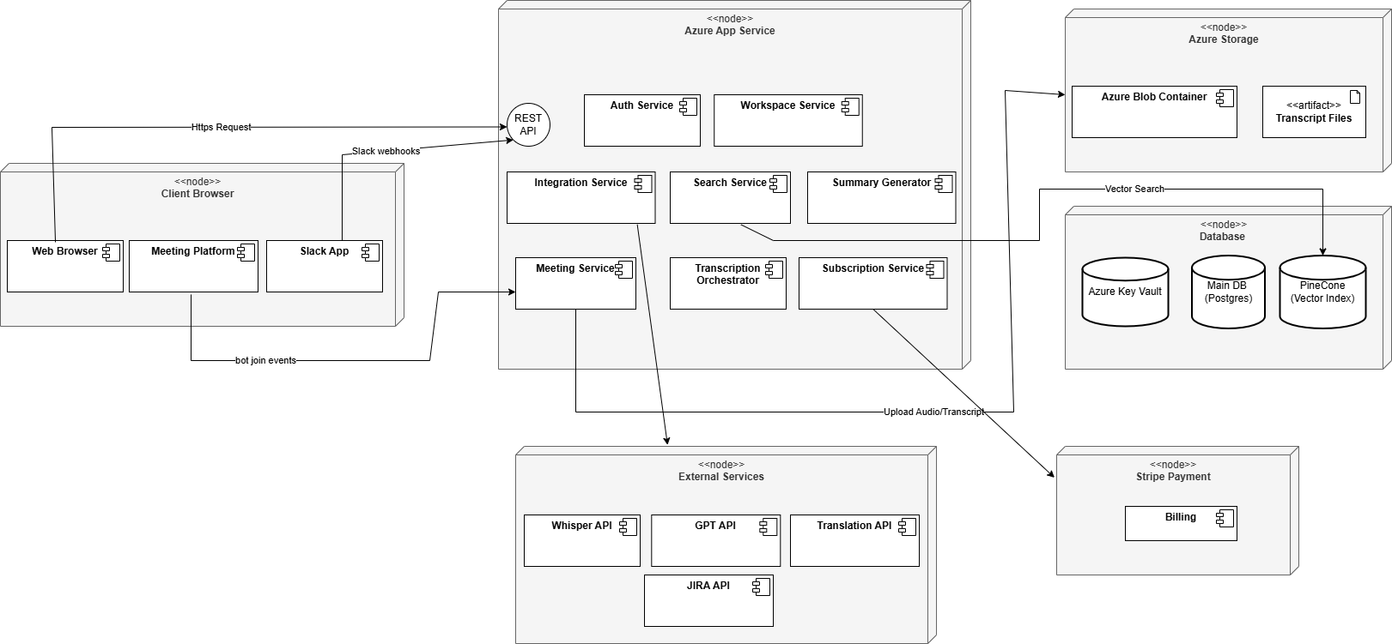
Figure 1. Deployment diagram
This deployment diagram shows IntelliMeet Pro running through a client browser that communicates with a central Azure App Service hosting all backend services, including authentication, meetings, integrations, search, transcription orchestration, summarization, and subscriptions. The backend connects to Azure Storage for transcript files, a database cluster containing the main Postgres DB, Key Vault, and Pinecone vector index, and various external APIs such as Whisper, GPT, Translation services, Jira, and conferencing platforms. Stripe Payment handles billing and subscription processing, completing the system's external integrations.

Software Architecture
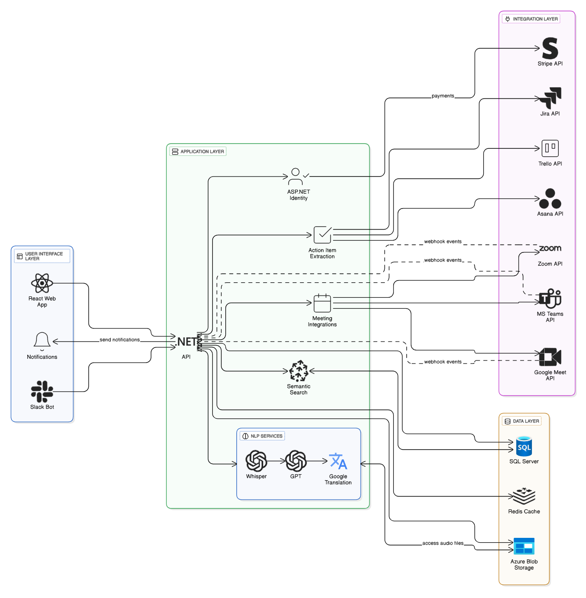
Figure 2. Architecture Diagram
This architecture diagram illustrates the layered design of IntelliMeet Pro, where the User Interface layer (React Web App, Slack Bot, Notifications) interacts with the central .NET API, which serves as the system’s orchestrator. The Application Layer handles authentication, meeting integrations, action item extraction, semantic search, and webhook processing, while the NLP Services layer provides AI-powered capabilities such as Whisper transcription, GPT summarization, and Google Translation. The Data Layer stores structured data in SQL Server, caches sessions in Redis, and saves audio files in Azure Blob Storage. Finally, the Integrations Layer connects the system to external services including Stripe for payments, Jira/Trello/Asana for task synchronization, and Zoom/Meet/Teams for meeting automation, enabling seamless communication through secure API calls and webhooks.

Design Strategy
The design strategy for IntelliMeet Pro establishes the guiding principles, abstractions, and structural decisions that shape the system’s overall organization. This strategy ensures that the system is modular, extensible, cloud-native, and resilient to changes in external APIs, AI model evolution, and user workflow requirements. It follows the Layered Architecture pattern defined in the architectural overview and builds upon core design goals such as scalability, maintainability, reusability, and adaptability.

Future System Extension or Enhancement
The system adopts a plug-and-play modular design where each major subsystem such as transcription, summarization, search, integrations, Slack bot, and payment management are encapsulated behind well-defined interfaces. The Integration Layer uses the Adapter Pattern to ensure that adding APIs requires minimal changes beyond the adapter.

Reasoning:
- High volatility in external API services (OpenAI, Zoom, Jira, Stripe) demands flexible, replaceable modules.
- A modular design enables incremental feature expansion without major architectural redesign.

Trade-offs:
- Increased upfront development effort due to abstraction layers.
- Additional interface contracts create overhead for a two-person team but significantly reduce long-term maintenance cost.

System Reuse
Core subsystems such as authentication, meeting ingestion pipeline, diarization workflow, semantic search, and workspace management are designed as reusable services that can be utilized by any client (web app, Slack bot, or third-party system). Reuse is supported through:
- Centralized backend APIs following REST conventions.
- Shared service layer for AI pipelines and integration logic.
- Configurable workflow orchestrators and reusable data models (e.g., Meeting, Transcript, Summary, ActionItem).
Reasoning:
- Enables multi-client architecture without duplicating logic.
- Supports future expansion into desktop/mobile apps or external API consumers.
- Enhances maintainability by centralizing business logic.

Trade-offs:
- Requires careful interface design to avoid leaking presentation concerns into backend services.
- Slight learning curve for maintaining strict separation of concerns.

User Interface Paradigms
The UI follows a component-based, reactive paradigm using React and modern UI libraries (TailwindCSS 4, Shadcn). Key strategies include:
- Separation of UI state from server state using React Query / SWR patterns.
- Use of async UI interactions to prevent blocking or freezing during large processing tasks.
- A dashboard-driven UX emphasizing summaries, action items, and searchable transcripts.
- Real-time updates via web sockets/event streams for transcription progress and notifications.
Reasoning:
- Meeting-related workflows require clear visualization of transcripts, summaries, and progress states.
- Slack bot interactions follow a conversational paradigm for quick queries.
- User paradigms focus on simplicity, productivity, and reducing cognitive load.

Trade-offs:
- Complex front-end state management.
- Requires careful handling of real-time events to prevent UI inconsistency.

Data Management (Storage, Distribution, Persistence)
Data is distributed across three specialized storage systems based on access patterns:
- Azure SQL Database – structured data (users, meetings, summaries, action items).
- Azure Blob Storage – large binary objects (audio files, user profile media).
- Pinecone Vector Index – semantic embeddings for search and RAG workflows.
Key strategies include:
- Normalized SQL schema for relational consistency.
- Metadata-based partitioning in Pinecone for fast multi-meeting filtering.
- Event-driven pipeline for moving raw audio → transcript → summarized metadata.
- Use of Azure Key Vault for secure secret storage.
- Caching frequently accessed queries in Redis.
Reasoning:
- Each storage technology is selected based on its strengths: relational integrity, large-file efficiency, vector search optimization.
- Pipeline design supports asynchronous processing without blocking UI interactions.

Trade-offs:
- Multi-store architecture increases system complexity.
- Requires synchronization logic to ensure consistency across stores.
- Higher operational overhead compared to a single-database approach.

Concurrency and Synchronization
Concurrency in IntelliMeet Pro is managed using:
- Asynchronous processing pipelines via Azure Functions.
- Queue-based event orchestration, ensuring ordered processing of meeting events.
- Optimistic concurrency in SQL through EF Core.
- Background workers for diarization, summarization, embedding generation, and integration with Jira/Asana/Trello.
- Thread-safe caching and distributed locks when necessary (via Redis).
Synchronization ensures that:
- Summaries are not generated before transcripts are finalized.
- Vector embeddings are indexed only after transcripts are stored.
- Action items are synced only after summary generation.
Reasoning:
- Meeting processing involves long-running tasks (transcription, diarization, LLM summarization).
- Real-time UI interactions require non-blocking, event-driven concurrency.
- Multi-step workflows must maintain logical order without sacrificing responsiveness.

Trade-offs:
- Event-driven systems are harder to debug due to distributed execution.
- Requires careful design of idempotent operations to avoid duplicated processing.
- More complex than synchronous, linear pipelines but significantly more scalable and reliable.

Detailed System Design

Database Design

Class Diagram
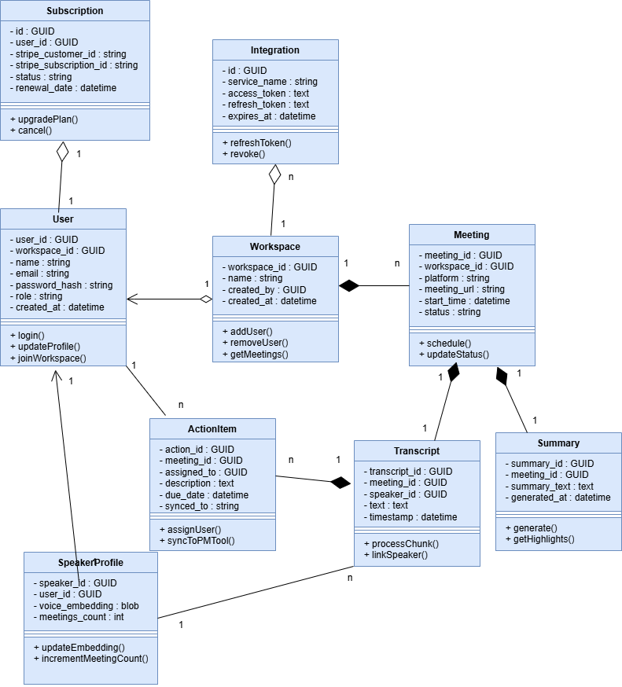
Figure 3. Class Diagram

    - ER Diagram

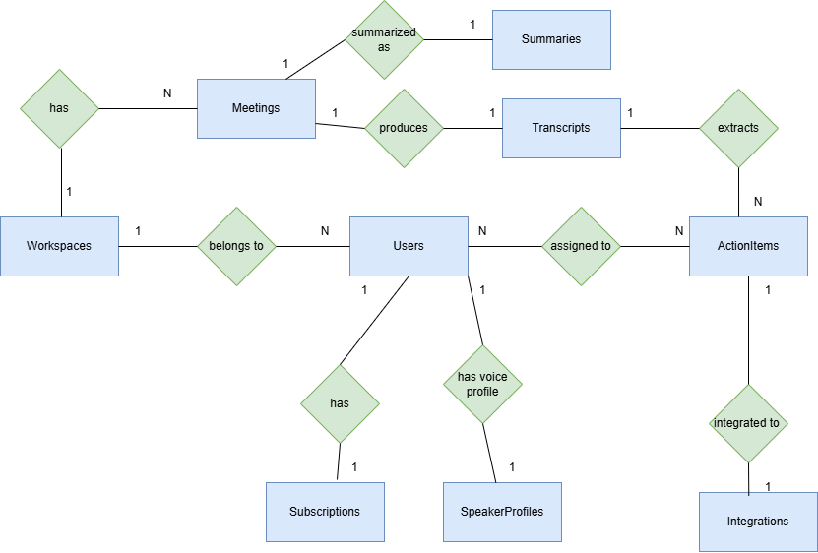
Figure 4. ER Diagram

Data Dictionary

Users
Users
Name | The user that will use our product
Alias | User
Where-used/how-used | Users represent all individuals who log into IntelliMeet Pro, including workspace owners (admins) and members. They authenticate through the system using email/password, receive verification emails, join workspaces, and perform actions such as querying transcripts, generating summaries, reviewing tasks, and receiving Slack responses.
Content description | Stores profile, credentials, workspace association, and authorization roles.
Column | Description | Type | Length | Nullable | Default value | Key
user_id | unique identifier | GUID | 36 | No | None | PK
workspace_id | FK to workspace | GUID | 36 | No | None | FK
name | Full name | varchar(256) | 256 | No | None | -
email | unique email | varchar(256) | 256 | No | None | Unique
password_hash | hashed password | varchar(512) | 512 | No | None | -
role | Admin / Member | varchar(50) | 50 | No | None | -
created_at | timestamp | datetime | - | No | Current timestamp | -
Table 1. Users

Workspaces
Workspaces
Name | The workspace area created for user to manage meetings
Alias | Organizations / Teams
Where-used/how-used | A workspace groups users, meetings, transcripts, and summaries under one collaborative entity. Every user belongs to a workspace, and all meetings, integrations, and permissions derive from workspace ownership. Admins manage members, authorize Slack + PM integrations, and control settings.
Content description | Stores high-level grouping for accounts and meeting data.
Column | Description | Type | Length | Nullable | Default value | Key
workspace_id | unique id | GUID | 36 | No | None | PK
name | workspace name | varchar(256) | 256 | No | None | -
created_by | owner | GUID | 36 | No | None | FK
created_at | timestamp | datetime | - | No | Current timestamp | -
password_hash | hashed password | varchar(512) | 512 | No | None | -
role | Admin / Member | varchar(50) | 50 | No | None | -
created_at | timestamp | datetime | - | No | Current timestamp | -
Table 2. Workspaces

Meetings
Meetings
Name | Meetings of a user
Alias | Meeting
Where-used/how-used | Represents scheduled meetings that the IntelliMeet Pro bot must join at the specified time. Used during scanning, bot joining, transcription, diarization, summary generation, action item creation, and semantic search indexing.
Content description | Metadata for scheduled and completed meetings.
Column | Description | Type | Length | Nullable | Default value | Key
meeting_id | meeting id | GUID | 36 | No | None | PK
workspace_id | FK | GUID | 36 | No | None | FK
platform | Zoom/Meet/Teams | varchar(50) | 50 | No | None | -
meeting_url | join link | varchar(512) | 512 | No | None | -
start_time | scheduled time | datetime | - | No | None | -
status | scheduled/ongoing/completed | varchar(50) | 50 | No | None | -
Table 3. Meetings

Transcripts
Transcripts
Name | Written record of every meeting
Alias | Transcripts
Where-used/how-used | Stores the audio-to-text output from Whisper API along with diarization results. Used for RAG search, summary generation, Slack Q&A, action item extraction, and semantic search embedding.  Each chunk is tied to a meeting and may link to a speaker profile.
Content description | Contains processed transcript chunks with timestamps and speaker attribution.
Column | Description | Type | Length | Nullable | Default value | Key
transcript_id | PK | GUID | 36 | No | None | PK
meeting_id | FK | GUID | 36 | No | None | FK
speaker_id | diarized speaker | GUID | 36 | Yes | None | FK
text | transcript text | TEXT | - | No | None | -
timestamp | chunk time | datetime | - | No | None | -
Table 4. Transcripts

Summaries
Summaries
Name | Performance stats for the employee
Alias | AI-Generated Meeting Summary
Where-used/how-used | Created automatically after a meeting ends. GPT uses transcript and embeddings to produce high-level summaries and action items. These summaries appear on dashboards, Slack summaries, PM tool syncing, and semantic search.
Content description | Stores generated summaries with timestamps.
Column | Description | Type | Length | Nullable | Default value | Key
summary_id | summary id | GUID | 36 | No | None | PK
meeting_id | FK | GUID | 36 | No | None | FK
summary_text | text | TEXT | - | No | None | -
generated_at | datetime | No | - | No | None | -
Table 5. Summaries

Action Items
ActionItems
Name | The tasks extracted from transcription
Alias | Action Items
Where-used/how-used | Generated by the summary engine and synced with Jira, Trello, Asana. Used to track responsibilities, deadlines, and action follow-up.
Content description | Stores actionable tasks extracted from meetings.
Column | Description | Type | Length | Nullable | Default value | Key
action_id | item id | GUID | 36 | No | None | PK
meeting_id | FK | GUID | 36 | No | None | FK
assigned_to | user | GUID | 36 | Yes | None | -
description | text | TEXT | - | Yes | None | -
due_date | Due date | datetime | - | Yes | None | -
synced_to | Jira/Trello/Asana | varchar(50) | 50 | Yes | None | -
Table 6. Action Items

Speaker Profiles
SpeakerProfiles
Name | Identity of each speaker/user
Alias | Voice Identity Records
Where-used/how-used | Used to improve diarization accuracy by maintaining speaker embeddings.  The system can map recurring voices to users, improving accuracy over multiple meetings.  Supports features like identifying unknown speakers and building speaker statistics.
Content description | Stores voice embeddings and optional links to existing users.
Column | Description | Type | Length | Nullable | Default value | Key
speaker_id | speaker profile | GUID | 36 | No | None | PK
user_id | optional link | GUID | 36 | Yes | None | FK
voice_embedding | vector | blob | - | No | None | -
meetings_count | Number of meetings spoken in | int | - | No | None | -
Table 7. Speaker Profiles

Integrations
Integrations
Name | Integrations
Alias | Connected Accounts / OAuth Tokens
Where-used/how-used | Stores tokens and configuration for external services: Slack bot authentication, Zoom/Meet/Teams bot access, Jira / Trello / Asana OAuth tokens
Content description | Stores encrypted integration credentials and metadata.
Column | Description | Type | Length | Nullable | Default value | Key
id | record id | GUID | 36 | No | None | PK
service_name | Jira/Slack/Asana/etc. | varchar(100) | 100 | No | None | -
access_token | OAuth token | TEXT | - | No | None | -
refresh_token | refresh token | TEXT | - | Yes | None | -
expires_at | expiry time | datetime | - | Yes | None | -
Table 8. Integrations

Subscriptions
Subscriptions
Name | The selected plan of each user
Alias | Billing / Stripe Records
Where-used/how-used | Tracks paid plans, subscription tiers, and Stripe billing sessions. Used for restricting feature access (e.g., number of meetings/month).
Content description | Stores subscription details returned by Stripe.
Column | Description | Type | Length | Nullable | Default value | Key
id | subscription id | GUID | 36 | No | None | PK
user_id | FK to user | GUID | 36 | No | None | FK
stripe_customer_id | Stripe customer | varchar(200) | 200 | No | None | -
stripe_subscription_id | Stripe subscription | varchar(200) | 200 | No | None | -
status | active/canceled | varchar(50) | 50 | No | None | -
renewal_date | datetime | - | - | No | none | -
Table 9. Subscriptions

Application Design

Sequence Diagram

User Registration + User Login
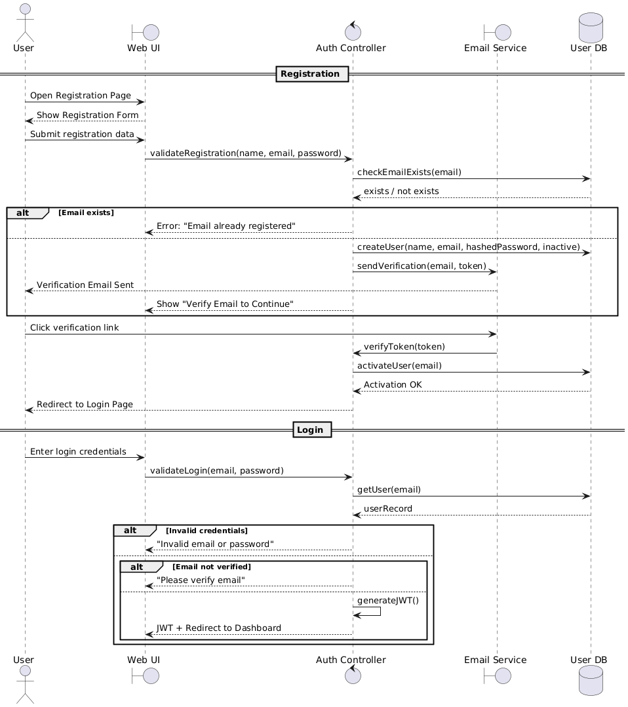
Figure 5. Sequence Diagram 1
The user begins by opening the registration page, submitting their details, and the system validates the email, creates an inactive user, and sends a verification email. After clicking the verification link, the user’s account is activated, and they are redirected to the login page. During login, the system verifies credentials and checks email verification status. If all validations pass, the system generates a JWT token and redirects the user to the dashboard.

Create Workspace & Invite Members
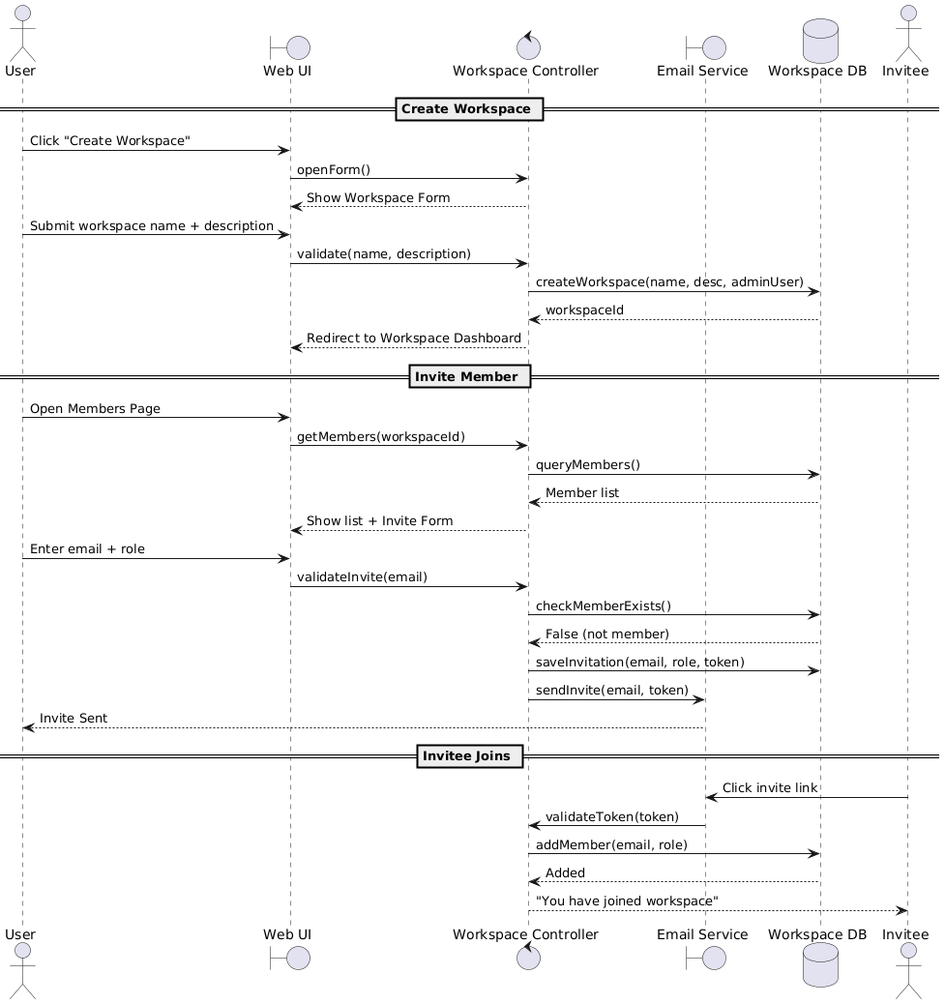
Figure 6. Sequence Diagram 2
The user opens the workspace creation form, provides the workspace details, and the system stores the new workspace and assigns the user as the admin. When inviting members, the user opens the Members page, reviews existing members, and submits an invite form. The system validates the invitee email, stores the invitation, sends an invite email, and once the invitee clicks the link, they are added to the workspace with the assigned role.

Schedule Meeting with AI Bot
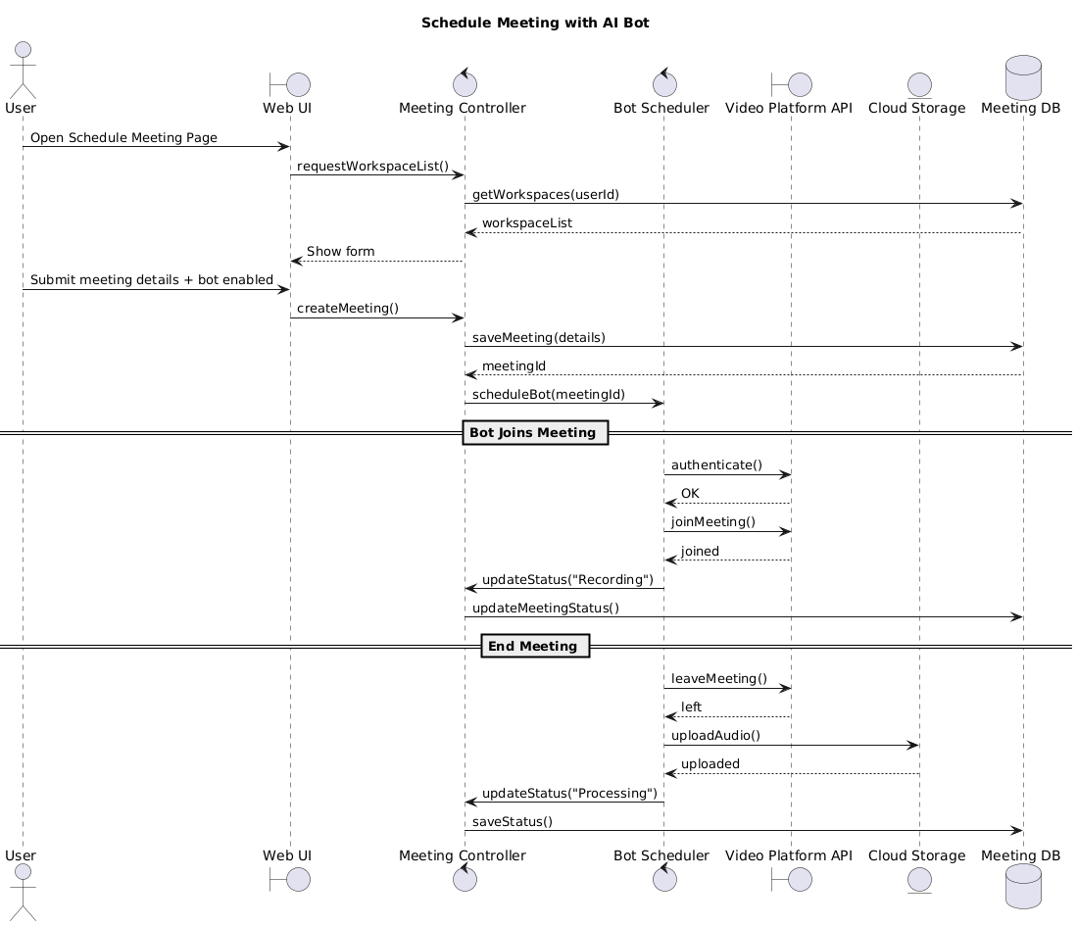
Figure 7. Sequence Diagram 3
The user accesses the meeting scheduling page, selects a workspace, enters meeting details, and chooses to deploy the AI bot. The system saves the meeting and schedules the bot. Before the meeting starts, the bot authenticates with the video platform, joins the meeting, records audio, and updates the meeting status. When the meeting ends, the bot leaves, uploads the audio to cloud storage, and marks the meeting as ready for processing.

Transcript + Summary + Urdu Translation
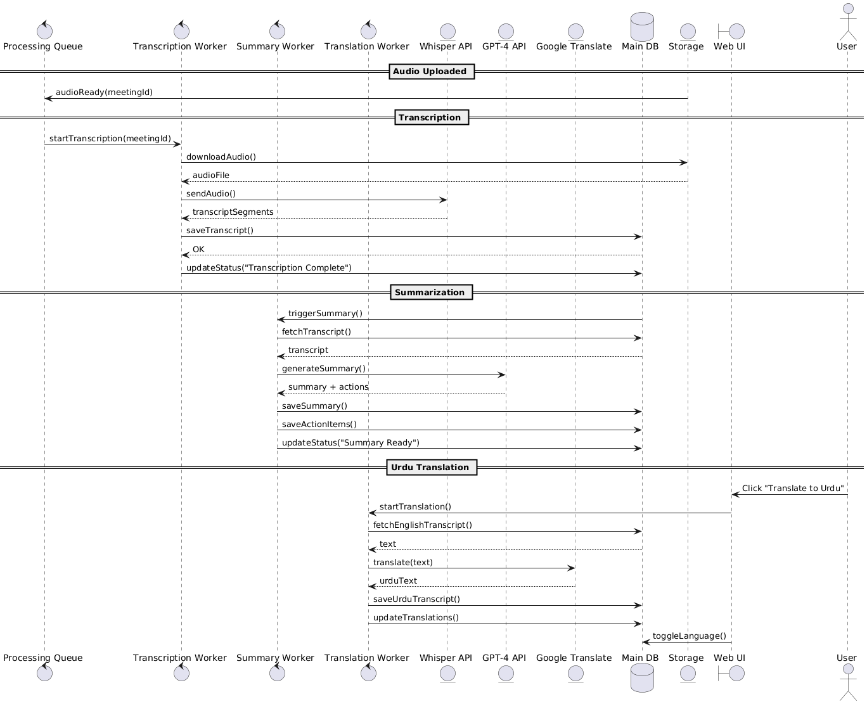
Figure 8. Sequence Diagram 4
Once the meeting audio is uploaded, the system queues a transcription task, downloads the audio, and processes it through Whisper to generate transcript segments. The system saves the transcript and triggers the summarization worker, which retrieves the transcript and uses GPT-4 to produce a structured summary and action items, storing both in the database. When the user requests translation, the translation worker fetches the transcript, sends text to Google Translate, stores the Urdu version, and updates available language options for viewing.

Semantic Search
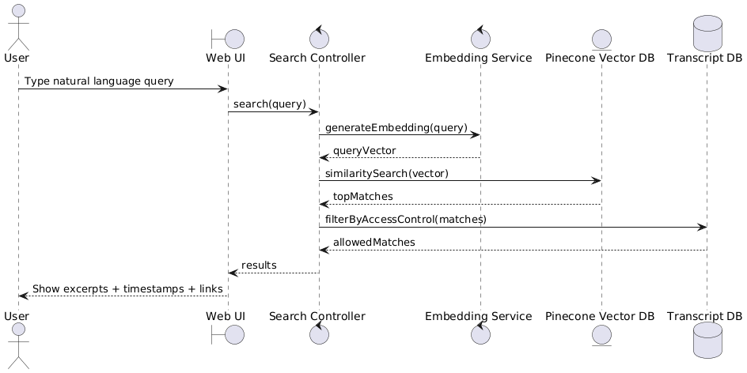
Figure 9. Sequence Diagram 5
The user enters a natural-language query in the UI, which is forwarded to the search controller. The system generates an embedding vector for the query, searches Pinecone for semantically similar transcript segments, and applies access-control filtering. The UI then displays the most relevant excerpts, including speaker information and direct links to the corresponding transcript sections.

Action items sync with PM tool (Jira Sync)
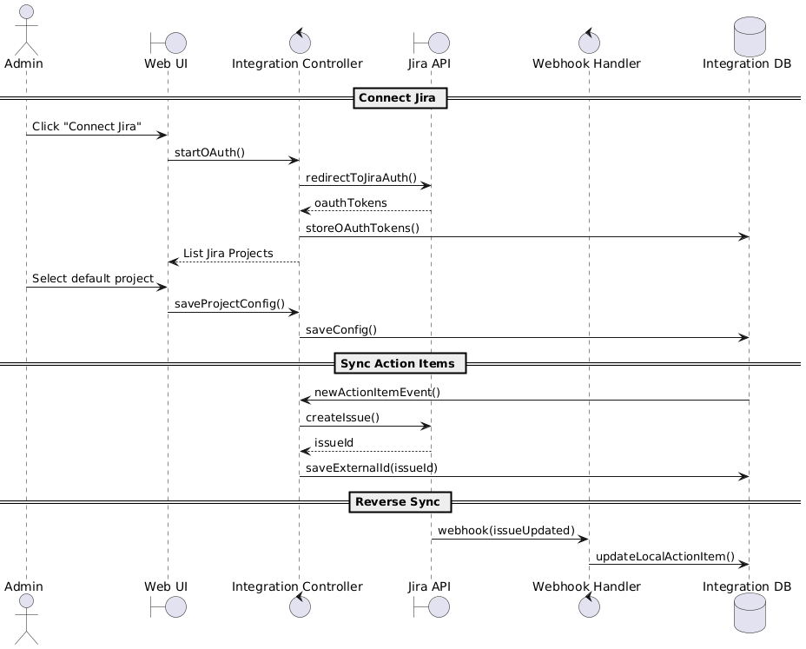
Figure 10. Sequence Diagram 6
The admin initiates Jira integration by starting OAuth, authorizing access, and selecting a default Jira project. The system stores OAuth tokens and configuration. When new action items are generated, the integration controller automatically creates corresponding Jira issues, stores their external IDs, and synchronizes updates. Incoming Jira webhook events update the corresponding local action item statuses in IntelliMeet Pro.

Query Meeting Content via Slack Bot
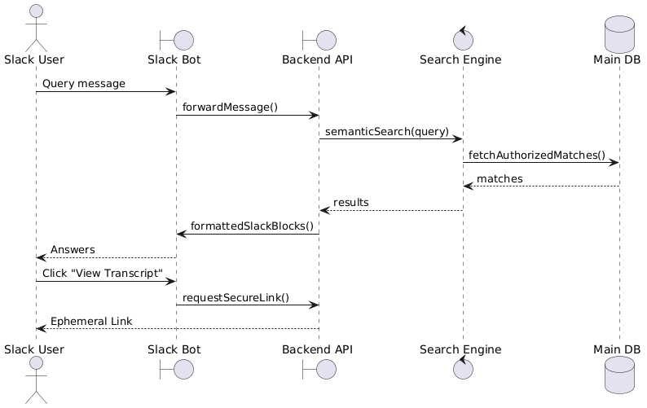
Figure 11. Sequence Diagram 7
The user sends a query to the Slack bot, which forwards the message to the backend API. The backend performs semantic search on meeting content, retrieves authorized results, and returns formatted Slack message blocks. The user may click “View Transcript,” prompting the bot to request a secure link from the backend and send it as an ephemeral message accessible only to the requesting user.

Subscribe to Professional Tier
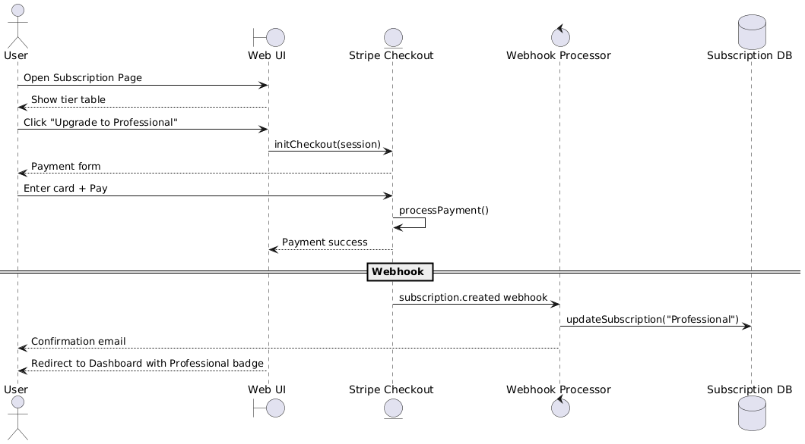
Figure 12. Sequence Diagram 8
The user opens the subscription page and chooses to upgrade. The system launches Stripe Checkout, where the user enters payment information. After successful payment, Stripe sends a webhook to the backend, which validates the event and updates the user’s subscription level. The system confirms the upgrade via email and updates the dashboard to show the Professional tier features.

State Diagram

Authentication & Account Lifecycle

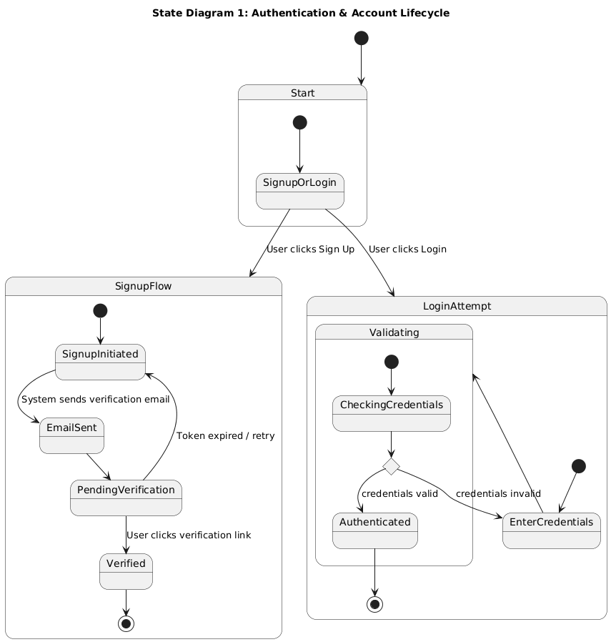
Figure 13. State Diagram 1
The overall login and signup process begins with users choosing whether to create an account or log in. New users complete the signup flow by receiving and confirming a verification email before accessing the system. Returning users enter their credentials, which are validated before granting access.

Meeting Processing Lifecycle
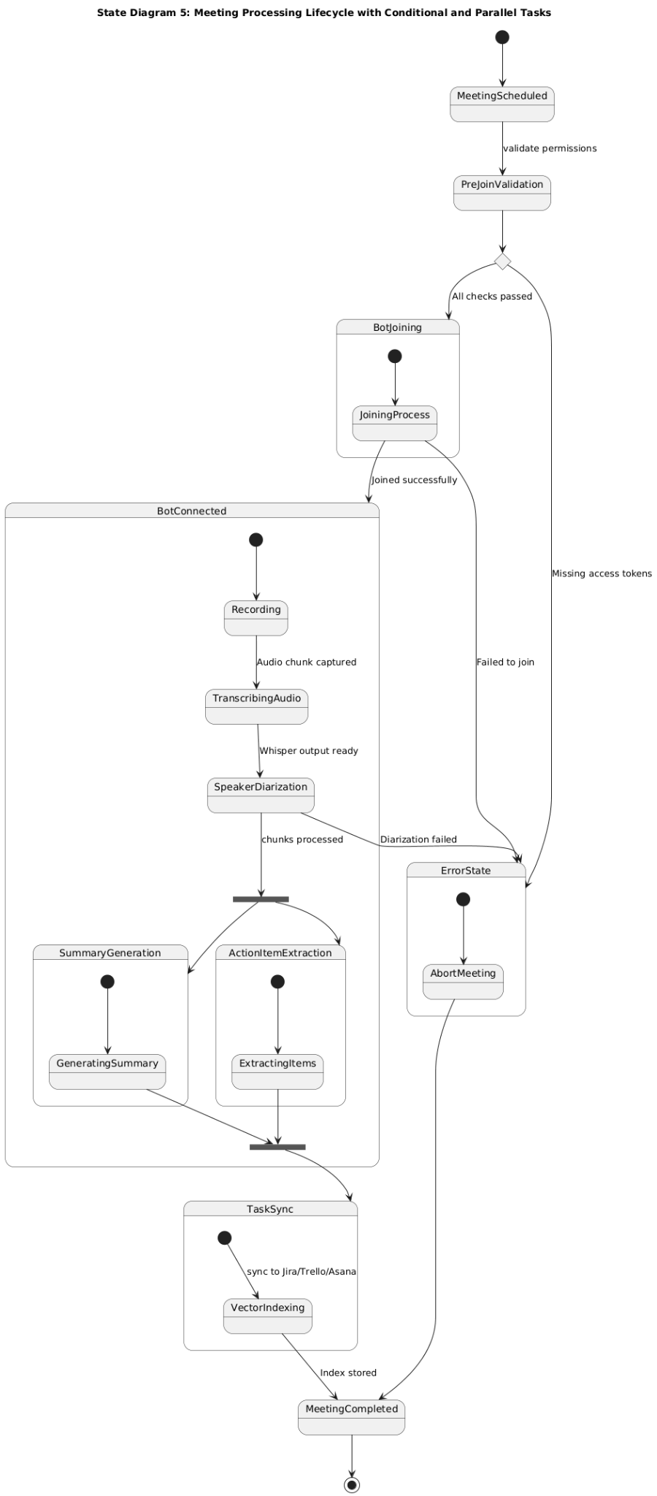
Figure 14. State Diagram 2
This shows the automated meeting life cycle. If a meeting is scheduled, and pre-join validation clears, the bot joins the meeting, otherwise moves to error state. During the meeting, the bot records audio, transcribes and performs speaker diarization. The audio is processed and forked into parallel tasks: summary generation and action item extraction. The action items are synchronized with PM tools through vector indexing. Any failures lead to an error state where the meeting is aborted. Upon successful completion of all steps or error handling, the meeting process is marked as completed.

RAG Semantic Search Flow
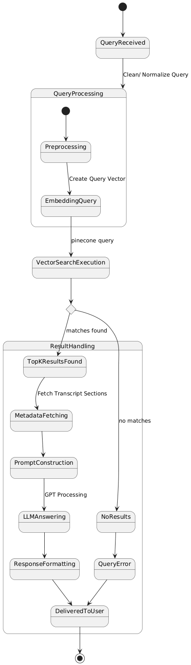
Figure 15. State Diagram 3
When a query is received, it is cleaned/normalized, then processed by creating a query vector. This vector triggers a vector search (e.g., Pinecone) to find relevant results. If matches are found, the top results are used to fetch metadata/transcript sections, construct a prompt, and format the response before delivering it to the user. If no results are found, the system triggers a query error, which is also delivered to the user.

Workspace & RBAC Flow
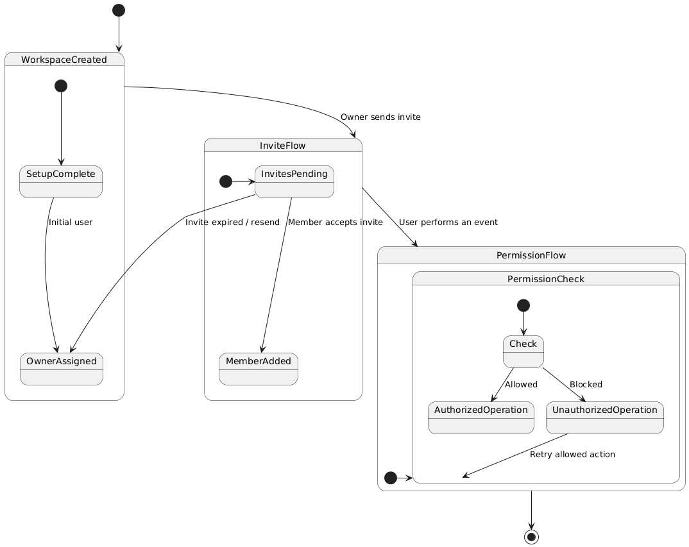
Figure 16. State Diagram 4
After a workspace is created, the initial user becomes the owner, who can then send invites to other members. Invitees move through the invite flow, where they either accept and become members or require a resend if the invite expires. When any user performs an action, the system enters the permission flow, where it checks whether the operation is authorized. Allowed actions proceed normally, while blocked actions return the user to retry with a permitted operation, and the process ends once permission handling is complete.

Payment & Subscription Lifecycle

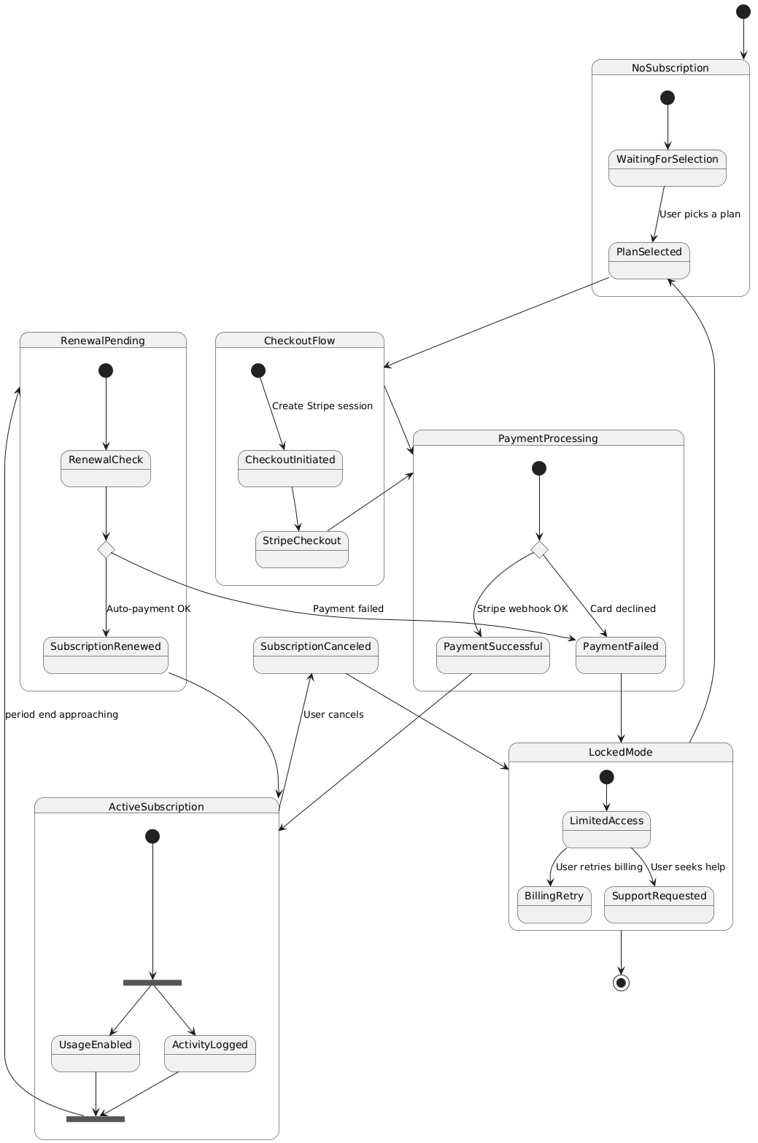
Figure 17. State Diagram 5
This is a full subscription lifecycle starting from a user with no subscription, who selects a plan and enters a checkout flow that creates a Stripe session and processes payment. Based on Stripe’s webhook, the payment either succeeds which will activate the subscription or fails, which will send the user into a locked mode with limited access until billing is retried, or support is requested. When active, the subscription runs parallel processes for enabling usage and logging activity, then moves toward renewal as the billing period ends. During renewal, auto-payment either successfully renews the subscription or fails, again transitioning the user to locked mode. Users may also cancel manually, which moves the system to a canceled state with restricted access, from which they may restart the subscription flow by selecting a plan again.

Data Flow Diagram

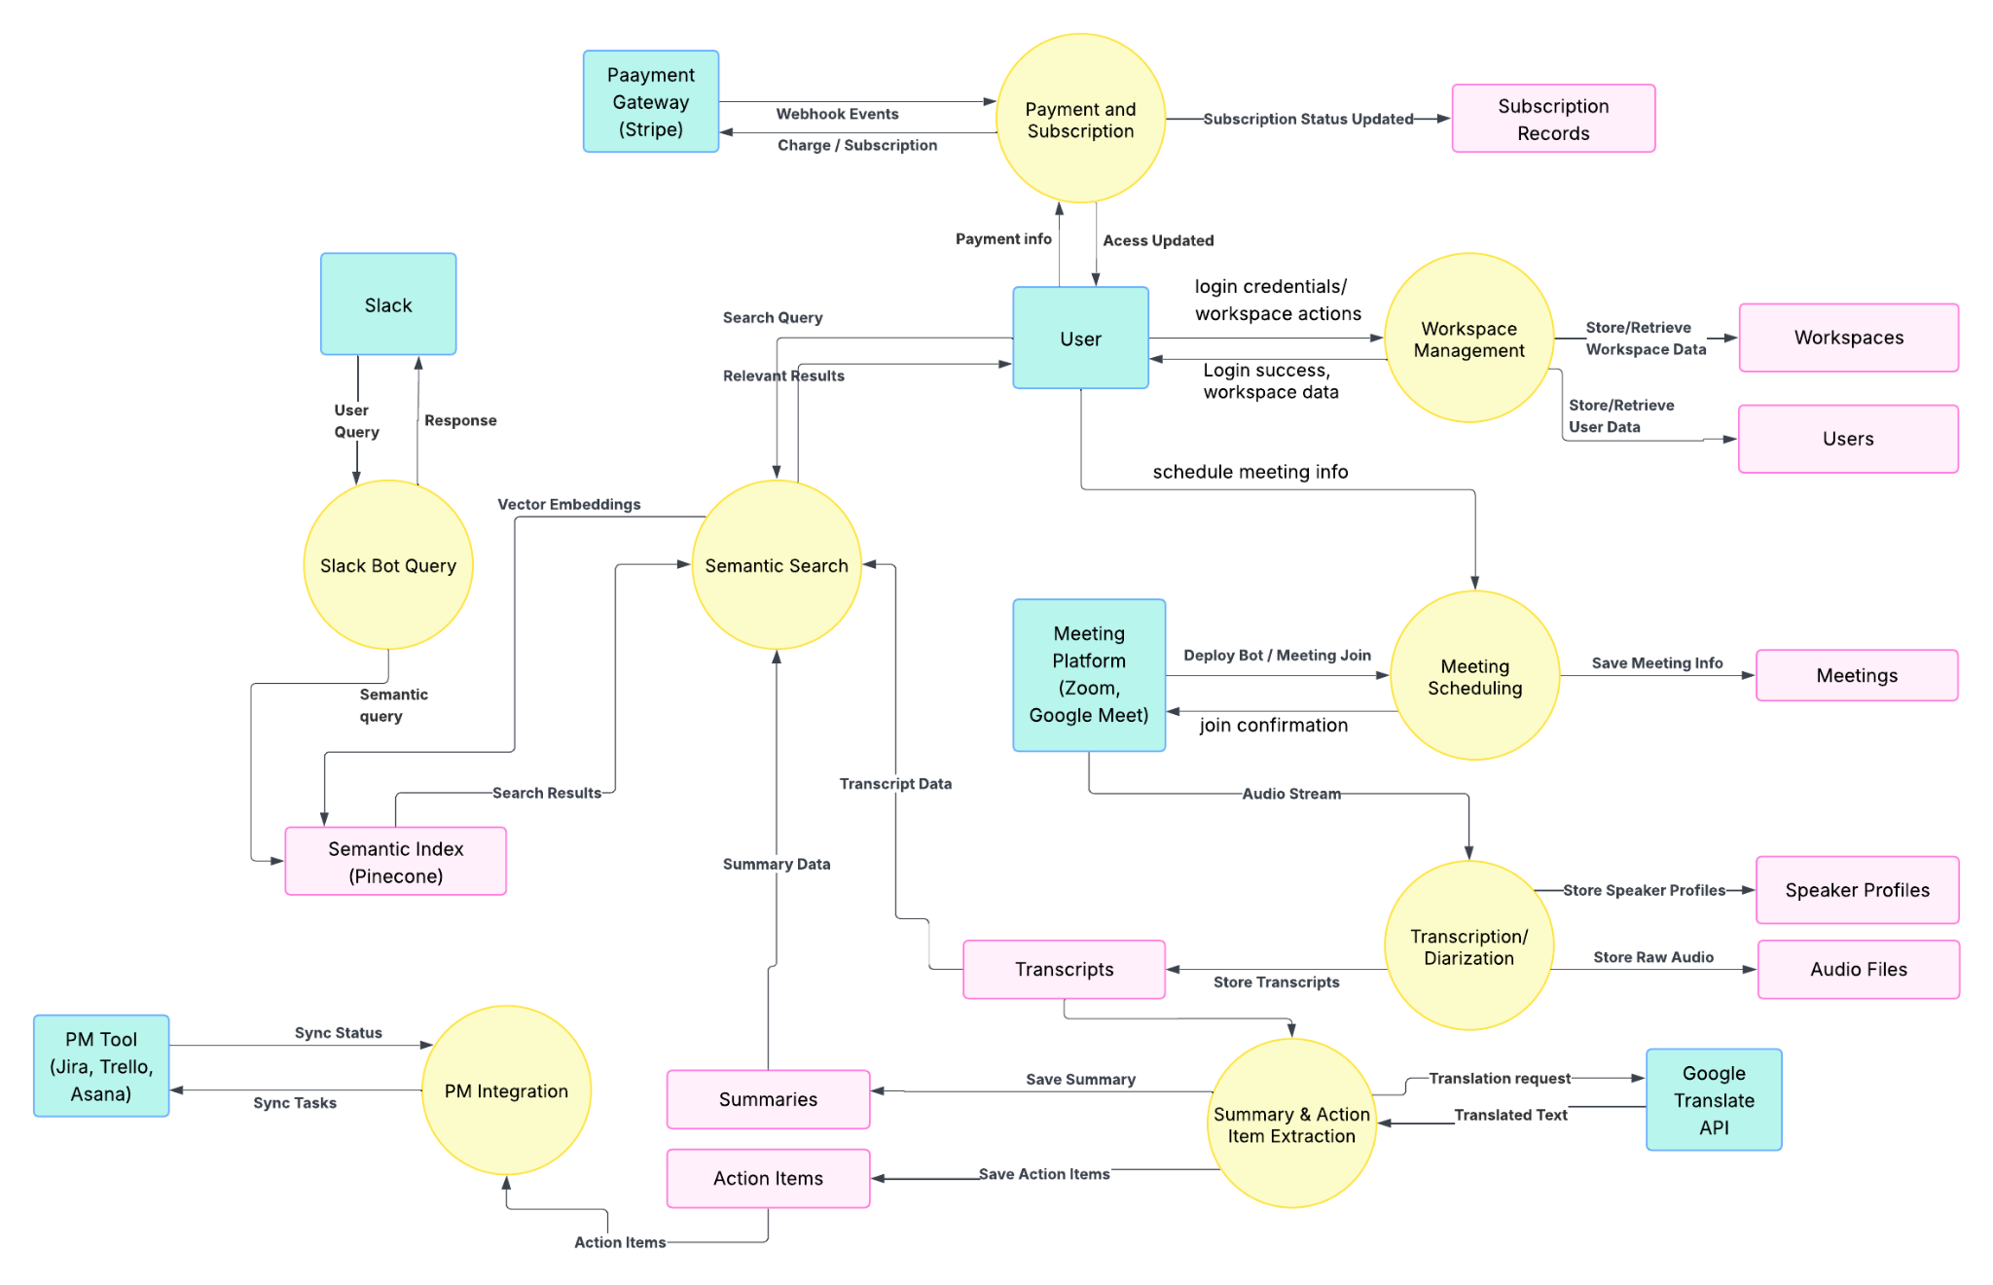
Figure 18. Data Flow Diagram

This DFD shows how IntelliMeet Pro processes meeting data end-to-end: the user authenticates, manages their workspace, and schedules meetings, which triggers the bot to join external meeting platforms. Audio from the meeting is sent to the transcription/diarization module, producing transcripts, speaker profiles, and audio files that feed into the summary and action item extraction process. Summaries and action items are stored and used by the semantic search engine, which also powers Slack bot queries. Action items are synced with external project management tools, while the payment system manages subscriptions through Stripe and updates access permissions.
6 References
- Jaime Teevan, Nancy Baym, Jenna Butler, Brent Hecht, Sonia Jaffe, Kate Nowak, Abigail Sellen, Longqi Yang, Marcus Ash, Kagonya Awori, Mia Bruch, Piali Choudhury, Adam Coleman, Scott Counts, Shiraz Cupala, Mary Czerwinski, Ed Doran, Elizabeth Fetterolf, Mar Gonzalez Franco, Kunal Gupta, Aaron L Halfaker, Constance Hadley, Brian Houck, Kori Inkpen, Shamsi Iqbal, Eric Knudsen, Stacey Levine, Siân Lindley, Jennifer Neville, Jacki O’Neill, Rick Pollak, Victor Poznanski, Sean Rintel, Neha Parikh Shah, Siddharth Suri, Adam D. Troy, and Mengting Wan. 2022. Microsoft New Future of Work Report 2022. Technical Report MSR-TR-2022-3. Microsoft. https://www.microsoft.com/enus/research/publication/microsoft-new-future-of-work-report-2022/
- Nicole Yankelovich, William Walker, Patricia Roberts, Mike Wessler, Jonathan Kaplan, and Joe Provino. 2004. Meeting Central: Making Distributed Meetings More Effective. In Proceedings of the 2004 ACM Conference on Computer Supported Cooperative Work (Chicago, Illinois, USA) (CSCW ’04). Association for Computing Machinery, New York, NY, USA, 419–428. https://doi.org/10.1145/1031607.1031678
- Vaiva Kalnikaite, Patrick Ehlen, and Steve Whittaker. 2012. Markup as You Talk: Establishing Effective Memory Cues While Still Contributing to a Meeting. In Proceedings of the ACM 2012 Conference on Computer Supported Cooperative Work (Seattle, Washington, USA) (CSCW ’12). Association for Computing Machinery, New York, NY, USA, 349–358. https://doi.org/10.1145/2145204.2145260
- Senthil Chandrasegaran, Chris Bryan, Hidekazu Shidara, Tung-Yen Chuang, and Kwan-Liu Ma. 2019. TalkTraces: real-time capture and visualization of verbal content in meetings. In Proceedings of the 2019 CHI Conference on Human Factors in Computing Systems. 1–14.
- Xinyue Chen, Shuo Li, Shipeng Liu, Robin Fowler, and Xu Wang. 2023. MeetScript: Designing Transcript-based Interactions to Support Active Participation in Group Video Meetings. Proceedings of the ACM on Human-Computer Interaction 7, CSCW2 (2023), 1–32. https://doi.org/10.1145/3610196
- Otter.ai. 2023. https://help.otter.ai/hc/en-us/articles/5093383818263-Automated-Live-Summary-Overview
- Sumit Asthana, Sagih Hilleli, Pengcheng He, and Aaron Halfaker. 2023. Summaries, Highlights, and Action items: Design, implementation and evaluation of an LLM-powered meeting recap system. arXiv preprint arXiv:2307.15793 (2023).
- Gregorio Convertino, Helena M Mentis, Mary Beth Rosson, John M Carroll, Aleksandra Slavkovic, and Craig H Ganoe. 2008. Articulating common ground in cooperative work: content and process. In Proceedings of the SIGCHI conference on human factors in computing systems. 1637–1646.
- Ruochen Xu, Chenguang Zhu, and Michael Zeng. 2022. Narrate Dialogues for Better Summarization. In Findings of the Association for Computational Linguistics: EMNLP 2022. Association for Computational Linguistics, Abu Dhabi, United Arab Emirates, 3565–3575. https://doi.org/10.18653/v1/2022.findings-emnlp.261
- PlantUML website. https://plantuml.com/
- Lucidchart website. https://www.lucidchart.com/pages/data-flow-diagram
- GeekforGeeks website. https://www.geeksforgeeks.org/
- Xinyue Chen, Nathan Yap, Xinyi Lu, Aylin Gunal, and Xu Wang 2025. “MeetMap: Real-Time Collaborative Dialogue Mapping with LLMs in Online Meetings”. https://dl.acm.org/doi/10.1145/3711030
- S. Asthana, S. Hilleli, P. He, and A. Halfaker, “Summaries, highlights, and action items: Design, implementation and evaluation of an LLM-powered meeting recap system,” Proc. ACM Hum.-Comput. Interact., vol. 7, no. CSCW1, pp. 1–29, Apr. 2023, https://dl.acm.org/doi/10.1145/3711074
- M. T. R. Laskar, H. Ji, and J. Liu, “Query-OPT: Optimizing inference of large language models via multi-query instructions in meeting summarization,” in Proc. 2024 Conf. Empirical Methods in Natural Language Processing (EMNLP), Miami, FL, USA, Nov. 2024, pp. 1–12.
- F. Kirstein, D. Schlangen, and C. Malon, “Tell me what I need to know: Exploring LLM-based (personalized) abstractive multi-source meeting summarization,” arXiv preprint, https://arxiv.org/abs/2410.14545

7 Appendices
Figure 1. Deployment diagram 13
Figure 2. Architecture Diagram 14
Figure 3. Class Diagram 18
Figure 4. ER Diagram 19
Figure 5. Sequence Diagram 1 25
Figure 6. Sequence Diagram 2 26
Figure 7. Sequence Diagram 3 27
Figure 8. Sequence Diagram 4 28
Figure 9. Sequence Diagram 5 29
Figure 10. Sequence Diagram 6 30
Figure 11. Sequence Diagram 7 31
Figure 12. Sequence Diagram 8 31
Figure 13. State Diagram 1 32
Figure 14. State Diagram 2 33
Figure 15. State Diagram 3 34
Figure 16. State Diagram 4 35
Figure 17. State Diagram 5 36
Figure 18. Data Flow Diagram 37

Table 1. Users 20
Table 2. Workspaces 21
Table 3. Meetings 21
Table 4. Transcripts 22
Table 5. Summaries 22
Table 6. Action Items 23
Table 7. Speaker Profiles 23
Table 8. Integrations 24
Table 9. Subscriptions 24

